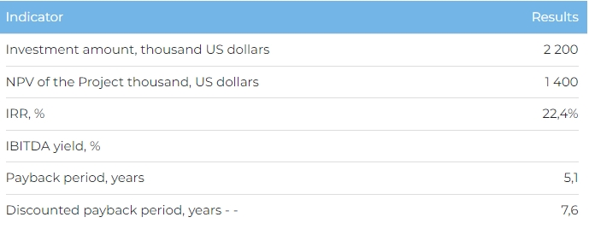Products
Upon reaching full design capacity in 2031, product range will be as follows: implants – 30 thousand; gum shapers – 21 thousand; abutments – 21 thousand; fixing screws – 21 thousand; transfer coping and equivalents – 21 thousand. The Initiator is planning for 44% of product to be sold domestically in Kazakhstan, with the remainder exported to Central Asian countries such as Uzbekistan, Kyrgyzstan, Tajikistan and Turkmenistan.
Project
This investment project envisages the construction of a plant to produce dental implants and protectors at the “Innovative Technology Park” Special Economic Zone in Almaty. Plant production capacity is up to 120 thousand items per year.
Current Project status:
- The Initiator has identified the supplier of production equipment as the Japanese company TSUGAMI. The following feedstock suppliers have also been identified: Zapp Precision Metals GmbH (Germany) for titanium pins and Himed (USA) for abrasive materials.
Project Initiator
The Initiator is Qazaq Implant LLP, which was created in 2023 to implement the Project. Its key personnel have many years of experience in selling implants and dental equipment.
Market overview
- In 2022, the global dental implant market was worth 4.7 billion USD. According to Technavio, this figure will reach 6.5 billion USD by 2027, with CAGR of 6.8% in 2023-2027. In 2022, the global dental market was worth 471 billion USD, and is due to reach 657 billion USD in 2027.
- In 2022, the dental market in Kazakhstan was worth 370 million USD (+82% from 2021), of which Astana and Almaty accounted for 38%.
What is the attractiveness of the project?
- Advantageous location. Having production based in the ITS SEZ will help cover the major consumer markets in the Almaty agglomeration. In addition, access to a well-developed and extensive rail and road network, and the Almaty international airport all benefit the supply of materials, as well as finished products to consumers.
- Import substitution with Kazakhstan products. The launch of a new plant will help stabilize the supply of Kazakhstan-made dental implants at a competitive price, significantly reducing import dependence. Furthermore, the use of production equipment from Japan, titanium rods from Germany and abrasive materials from the USA will help ensure product quality.
Investment proposal
The Project requires investment of 2,200 thousand USD (at the rate of 449.2 tenge), of which:
- 70% (1,540 thousand USD) – debt financing subject to collateral;
- 30% (660 thousand USD) – investor participation.
The proposed financing structure and state support measures are indicative. The final financing structure and Project interests will be determined based on the results of negotiations with the investor.
